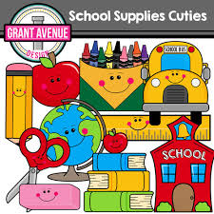
The Conrad Academy
First Grade Supply List
2022-2023

- 1 Pencil box
- 1 Plastic Shoe Box
- 30 Pencils
- 4 Pink erasers
- 1 Ruler (wooden) (No plastic or flexible rulers)
- 1 Pair of Fiskars Scissors (metal blades)
- 8 Count Box of Crayola Colored Pencils Assorted Colors
- 2 Boxes of Crayola Box Assorted Colors
- 6 Glue Sticks (Elmer’s Glue Stick)
- 3 -PLASTIC Folders (with prongs and bottom pockets solid colors 1 red, 1 blue, 1 yellow (No other colors)
- 1 – 1 ½ Inch (3 Ring Binder) Binder (Any Color)
- 3 Composition Notebooks 100/Sheets/200 pages 9 ¾ in x 7 ½ in Wide Ruled (No spirals) (Solid colors 1 red, 1 blue, 1 yellow) (No other colors)
- 2 Containers Lysol Wipes
- 2 Lysol Spray Bottles
- 2 Box of Tissues
- 1 Roll Paper Towel
- 2 Container of Baby Wipes
- 1 Box Ziplock Bags
- 1 Bottle Hand Sanitizer
- 1 Bottle Shaving Cream (any brand, not gel)

Wish List:
- Expo Markers (any colors)
- Stickers
- Treasure Box Items (small)

- The school will continue to follow the guidelines of CDC Department (Covid19).
- *Please label scissor, pencil box, shoe box, ruler, notebooks, folders, backpack, lunch box with your child’s name.

Revised: 5/27/22

