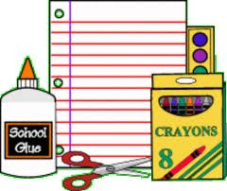 Kindergarten Supply List
*Please be sure to put your child’s name on your items*

1 Backpack
1 Lunch Box
2 (16 or 24 count) boxes of crayons
1 packs of 10 count pencils - #2
1 pack of Chubby pencils
1 (1 ½ inch) 3 ring binder
1 pack of pink eraser
1 pair of kid scissors
1 ruler – 6 inch
1 box of colored pencil
3 dry erase markers – chisel point
1 sturdy regular size pencil box
8 small glue sticks or 5 large glue sticks
1 pack of thin and thick paint brushes

2 playdough cans
1 bottle of liquid glue
1 pack of markers
10 pack of small kids paint
2 Rolls household paper towels
2 bottles of hand sanitizer
2 container of disinfecting wipes
1 package of baby wipes
2 boxes of tissues
1 box of Ziplock bags (any size)
1 package of assorted construction paper (8” by 12 “)
6 folders with pockets and prongs 2 red, 2 blue and 2 green
1 plastic shoe box with a lid
1 package of copy paper

