The Conrad Academy
Kindergarten Supply List

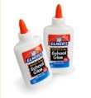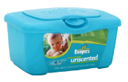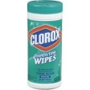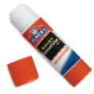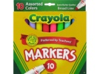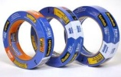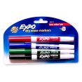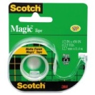
FOR OUR CLASSROOM: Your donations are greatly appreciated.

- One 4-pack of thin (skinny) Expo dry-erase markers; any color
- One-4-pack of thick (fat) Expo dry-erase markers; any color
- 4 - large Elmers glue sticks
- 1 - 24 pack of #2 pencils
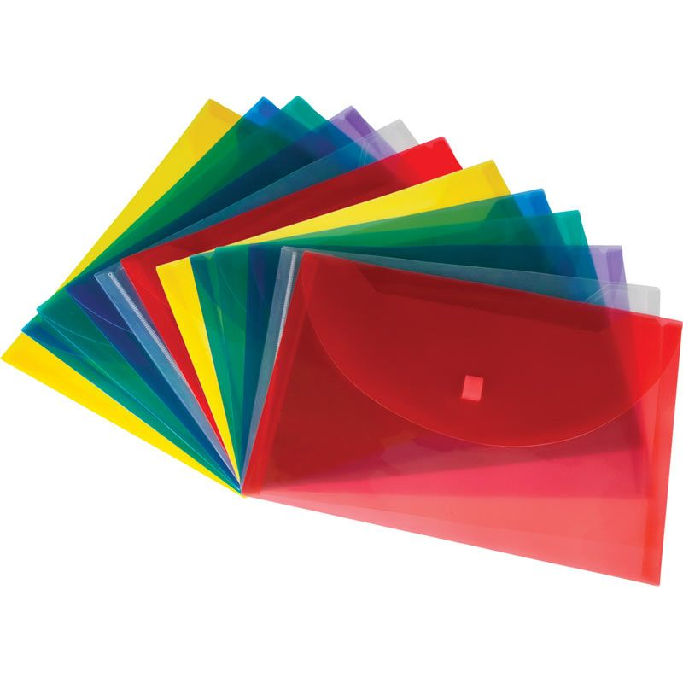
- 2 - Pocket folders (2 green)
- 3 – PLASTIC folders/envelope (1 blue, 2 yellow, 1 red)
- One Plastic School Box (8" x 5" approximately)
- One box of large Crayola markers; any colors
- 3-Boxes of 24 count Crayola Crayons (Please initial each crayon)
- 1 box of colored pencils
- 1 ream of computer paper
- 1 Avery sheet protector (25 pack)
- 2 pink erasers
- Pair of Fiskars child size scissors.
- 2 Bottle of Hand Sanitizer
- 1 can of Lysol spray
- 1 tub of baby wipes
- 3 boxes of Kleenex tissue
- 1 Roll of paper towels
- 2 Clorox wipes-not baby wipes
- 1 wrapped sponge for sponge painting without the scrubbing side
- 1 box of Ziploc Bags: Sandwich Size
- 1 box of Ziploc Bags: Gallon Size
- 1 box of Ziploc Bags: Quart Size
- 1 - 2" clear tape and 1- 1/2 inch clear tape

Please bring these supplies with your child to meet the teacher day. Place them inside a plastic bag and tie tight, tape a label to the bag with your child's name. Thanks!

